# Elizabeth Taylor BAN 502 Predictive Analytics

library(tidyverse) # read in the packages I need  
library(tidymodels)  
library(GGally) #ggcorr and ggpairs  
library(ggcorrplot) #correlation plot alternative  
library(gridExtra) #create grids of plots  
library(rpart)  
library(rpart.plot)  
library(RColorBrewer)  
library(rattle)  
library(caret)  
library(esquisse)

library(readr) #read in the data  
ames_student <- read_csv("ames_student.csv")

str(ames_student) #review the data

#esquisser(ames_student) Helped me visualize which variables might be strong predictors of Above Average

ames = ames_student%>%dplyr::select(Above_Median,Year_Built,Gr_Liv_Area, Lot_Area, Full_Bath,Half_Bath, TotRms_AbvGrd, Year_Built,Year_Sold, Three_season_porch,Screen_Porch )  
#These were the variables that I found that seemed to be good predictions of the variable Above_Median

ames = ames %>% mutate(Above_Median = as_factor(Above_Median))   
   
ames$TotBath <- ames$Full_Bath+ ames$Half_Bath  
ames$Porch <- ames$Three_season_porch+ames$Screen_Porch  
ames <- ames %>% select(-Full_Bath,-Half_Bath,-Three_season_porch,-Screen_Porch)  
#I decide to add both half bath and full bath together to create total bath as one variable.   
#I decided that a three season porch and screen porch were similar enough to add them together as one variable  
#Once I created the new variables I subtracted the old variables out of the data set.

#ggpairs(ames) #So I can visualize my variables on my data set

ggplot(ames) +  
 aes(x = TotBath, y = Above_Median) +  
 geom_boxplot(fill = "#112446") +  
 labs(  
 x = "Total number of Bathrooms",  
 y = "Sold Above Median Price",  
 title = "Total Bath"  
 ) +  
 theme_minimal()

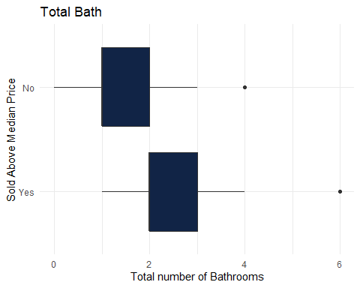

ggplot(ames) +  
 aes(x = Year_Built, y = Above_Median) +  
 geom_boxplot(fill = "#112446") +  
 labs(  
 x = "Year Built",  
 y = "Sold Above Median Price ",  
 title = "Year Built"  
 ) +  
 theme_minimal()

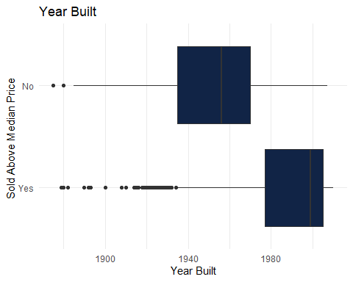

ggplot(ames) +  
 aes(x = Above_Median, y = Lot_Area) +  
 geom_boxplot(fill = "#112446") +  
 labs(  
 x = "Size of Lot",  
 y = "Sold Above Median Price",  
 title = "Size of Lot"  
 ) +  
 theme_minimal()

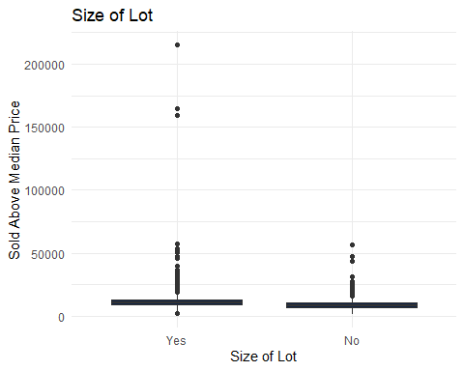

ggplot(ames) +  
 aes(x = TotRms_AbvGrd, y = Above_Median) +  
 geom_boxplot(fill = "#112446") +  
 labs(  
 x = "Total Rooms",  
 y = "Sold Above Median Price ",  
 title = "Total Rooms"  
 ) +  
 theme_minimal()

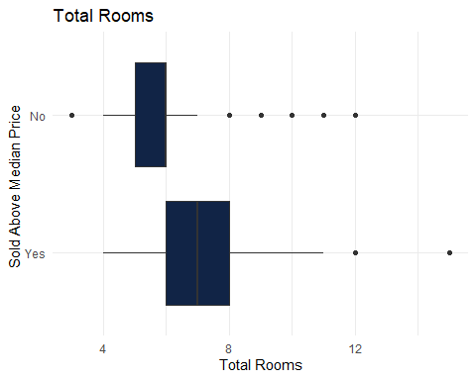

ggplot(ames) +aes(x = Porch, y = Above_Median) +  
 geom_col(fill = "#112446") +  
 labs(  
 x = "Porch",  
 y = "Sold Above Median Price ",  
 title = "Porch or 3 Season Room"  
 ) +  
 theme_minimal()

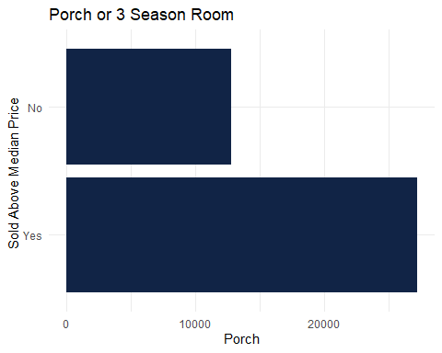

theme_minimal()  
ggplot(ames) +  
 aes(x = Above_Median, y = Gr_Liv_Area, ) +  
 geom_col(fill = "#112446") +  
 labs(  
 x = "Total Sq Footage",  
 y = "Sold Above Median Price ",  
 title = "Size of House"  
 ) +  
 theme_minimal()

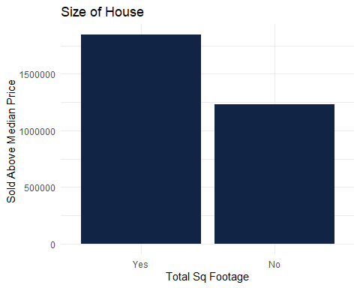

set.seed(123) #spliting in to the testing and training datasets  
#set up the vfolds   
ames_split = initial_split(ames, prop = 0.7, strata = Above_Median)   
train = training(ames_split)   
test = testing(ames_split)  
folds = vfold_cv(train, v = 10)

#creating my classification tree recipe with a complexity model to see the accuracy of the model   
ames_recipe = recipe(Above_Median ~., train) %>%  
 step_dummy(all_nominal(),-all_outcomes())  
  
tree_model = decision_tree(cost_complexity = tune()) %>%   
 set_engine("rpart", model = TRUE) %>%   
 set_mode("classification")  
  
tree_grid = grid_regular(cost_complexity(),  
 levels = 30)   
  
ames_wflow =   
 workflow() %>%   
 add_model(tree_model) %>%   
 add_recipe(ames_recipe)  
  
tree_res =   
 ames_wflow %>%   
 tune_grid(  
 resamples = folds,  
 grid = tree_grid  
 )  
  
tree_res

## # Tuning results  
## # 10-fold cross-validation   
## # A tibble: 10 × 4  
## splits id .metrics .notes   
## <list> <chr> <list> <list>   
## 1 <split [1293/144]> Fold01 <tibble [60 × 5]> <tibble [0 × 3]>  
## 2 <split [1293/144]> Fold02 <tibble [60 × 5]> <tibble [0 × 3]>  
## 3 <split [1293/144]> Fold03 <tibble [60 × 5]> <tibble [0 × 3]>  
## 4 <split [1293/144]> Fold04 <tibble [60 × 5]> <tibble [0 × 3]>  
## 5 <split [1293/144]> Fold05 <tibble [60 × 5]> <tibble [0 × 3]>  
## 6 <split [1293/144]> Fold06 <tibble [60 × 5]> <tibble [0 × 3]>  
## 7 <split [1293/144]> Fold07 <tibble [60 × 5]> <tibble [0 × 3]>  
## 8 <split [1294/143]> Fold08 <tibble [60 × 5]> <tibble [0 × 3]>  
## 9 <split [1294/143]> Fold09 <tibble [60 × 5]> <tibble [0 × 3]>  
## 10 <split [1294/143]> Fold10 <tibble [60 × 5]> <tibble [0 × 3]>

#the graph that shows the accuracy and ROC_AUC  
tree_res %>%  
 collect_metrics() %>%  
 ggplot(aes(cost_complexity, mean)) +  
 geom_line(size = 1.5, alpha = 0.6) +  
 geom_point(size = 2) +  
 facet_wrap(~ .metric, scales = "free", nrow = 2)

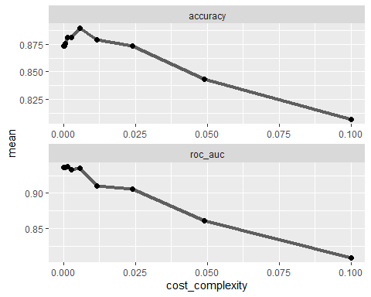

#choosing the tree with the best accuracy   
best_tree = tree_res %>%  
 select_best("accuracy")  
  
best_tree

## # A tibble: 1 × 2  
## cost_complexity .config   
## <dbl> <chr>   
## 1 0.00574 Preprocessor1_Model26

#finalizing the workflow  
final_wf =   
 ames_wflow %>%   
 finalize_workflow(best_tree)

#fitting to the training set  
final_fit = fit(final_wf, train)  
  
tree = final_fit %>%   
 extract_fit_parsnip() %>%   
 pluck("fit")  
  
fancyRpartPlot(tree, tweak = 2.2)

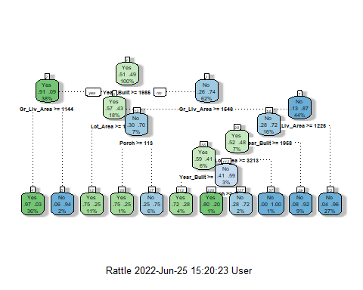

treepred = predict(final_fit, train, type = "class")

confusionMatrix(treepred$.pred_class,train$Above_Median,positive="Yes")

## Confusion Matrix and Statistics  
##   
## Reference  
## Prediction Yes No  
## Yes 672 75  
## No 58 632  
##   
## Accuracy : 0.9074   
## 95% CI : (0.8913, 0.9219)  
## No Information Rate : 0.508   
## P-Value [Acc > NIR] : <2e-16   
##   
## Kappa : 0.8148   
##   
## Mcnemar's Test P-Value : 0.1653   
##   
## Sensitivity : 0.9205   
## Specificity : 0.8939   
## Pos Pred Value : 0.8996   
## Neg Pred Value : 0.9159   
## Prevalence : 0.5080   
## Detection Rate : 0.4676   
## Detection Prevalence : 0.5198   
## Balanced Accuracy : 0.9072   
##   
## 'Positive' Class : Yes   
##

#making predictions on tje testing set   
treepred_test = predict(final_fit, test, type = "class")  
head(treepred_test)

## # A tibble: 6 × 1  
## .pred_class  
## <fct>   
## 1 No   
## 2 Yes   
## 3 Yes   
## 4 Yes   
## 5 Yes   
## 6 Yes

#To see the Confusion Matrix with accuracy sensitivity and Specificity  
confusionMatrix(treepred_test$.pred_class,test$Above_Median,positive="Yes")

## Confusion Matrix and Statistics  
##   
## Reference  
## Prediction Yes No  
## Yes 271 40  
## No 42 263  
##   
## Accuracy : 0.8669   
## 95% CI : (0.8375, 0.8927)  
## No Information Rate : 0.5081   
## P-Value [Acc > NIR] : <2e-16   
##   
## Kappa : 0.7337   
##   
## Mcnemar's Test P-Value : 0.9121   
##   
## Sensitivity : 0.8658   
## Specificity : 0.8680   
## Pos Pred Value : 0.8714   
## Neg Pred Value : 0.8623   
## Prevalence : 0.5081   
## Detection Rate : 0.4399   
## Detection Prevalence : 0.5049   
## Balanced Accuracy : 0.8669   
##   
## 'Positive' Class : Yes   
##

#tuning  
  
ames_recipe = recipe(Above_Median ~., train) %>%   
 step_dummy(all_nominal(),-all_outcomes())  
  
tree_model = decision_tree(cost_complexity = tune()) %>%   
 set_engine("rpart", model = TRUE) %>% #don't forget the model = TRUE flag  
 set_mode("classification")  
  
tree_grid = expand.grid(cost_complexity = seq(0.001,0.01,by=0.001))  
  
ames_wflow =   
 workflow() %>%   
 add_model(tree_model) %>%   
 add_recipe(ames_recipe)  
  
tree_res =   
 ames_wflow %>%   
 tune_grid(  
 resamples = folds,  
 grid = tree_grid  
 )  
  
tree_res

## # Tuning results  
## # 10-fold cross-validation   
## # A tibble: 10 × 4  
## splits id .metrics .notes   
## <list> <chr> <list> <list>   
## 1 <split [1293/144]> Fold01 <tibble [20 × 5]> <tibble [0 × 3]>  
## 2 <split [1293/144]> Fold02 <tibble [20 × 5]> <tibble [0 × 3]>  
## 3 <split [1293/144]> Fold03 <tibble [20 × 5]> <tibble [0 × 3]>  
## 4 <split [1293/144]> Fold04 <tibble [20 × 5]> <tibble [0 × 3]>  
## 5 <split [1293/144]> Fold05 <tibble [20 × 5]> <tibble [0 × 3]>  
## 6 <split [1293/144]> Fold06 <tibble [20 × 5]> <tibble [0 × 3]>  
## 7 <split [1293/144]> Fold07 <tibble [20 × 5]> <tibble [0 × 3]>  
## 8 <split [1294/143]> Fold08 <tibble [20 × 5]> <tibble [0 × 3]>  
## 9 <split [1294/143]> Fold09 <tibble [20 × 5]> <tibble [0 × 3]>  
## 10 <split [1294/143]> Fold10 <tibble [20 × 5]> <tibble [0 × 3]>

#after tuning find the tree with the best accuracy   
tree_res %>%  
 collect_metrics() %>%  
 ggplot(aes(cost_complexity, mean)) +  
 geom_line(size = 1.5, alpha = 0.6) +  
 geom_point(size = 2) +  
 facet_wrap(~ .metric, scales = "free", nrow = 2)

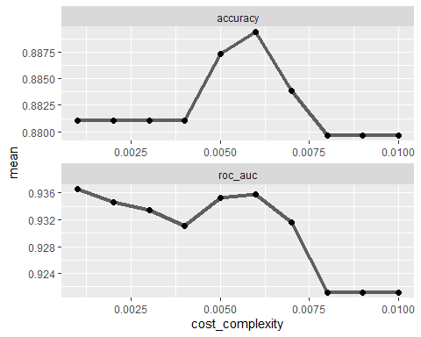

best_tree = tree_res %>%  
 select_best("accuracy")  
  
best_tree

## # A tibble: 1 × 2  
## cost_complexity .config   
## <dbl> <chr>   
## 1 0.006 Preprocessor1_Model06

final_wf =   
 ames_wflow %>%   
 finalize_workflow(best_tree)

final_fit = fit(final_wf, train)  
  
tree = final_fit %>%   
 extract_fit_parsnip() %>%   
 pluck("fit")  
  
fancyRpartPlot(tree, tweak = 2)



